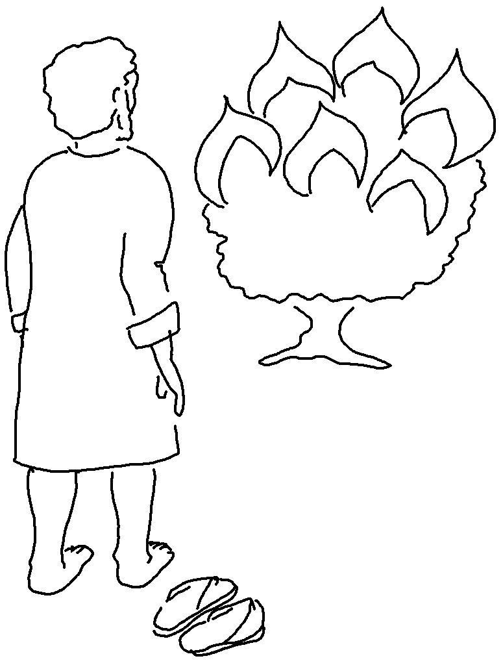
Come, let us _ _ _ _ _ _ _ and bow down. Let us kneel before the _ _ _ _ our _ _ _ _ _. Psalms 95:6_{NLT}

